**Write a C program to search a number using Linear Search method**

**INPUT:**

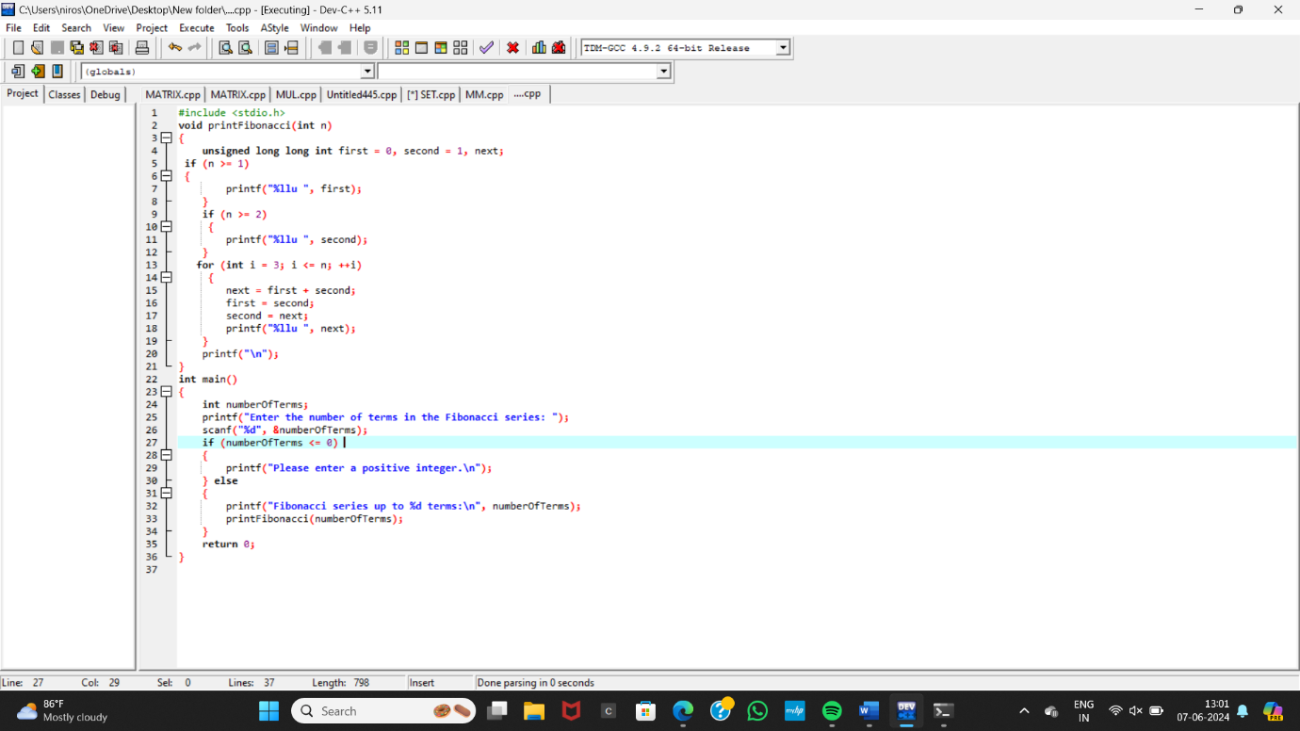

**OUTPUT:**

